Ocean Equilibria & Atmospheric CO₂ Equations
[1] The ocean acts as a sink for some of the atmospheric CO₂:
$${CO}_{2 (g)}⇌{CO}_{2 (aq)}$$

[2] Some of the dissolved CO₂ can react with water to form H₂CO₃:
$${CO}_{2 (aq)}+H_{2}O_{(l)}⇌H_{2}{CO}_{3 (aq)}$$

[3] H₂CO₃ partially ionises to form H₃O⁺ ions.
$$H_{2}{CO}_{3 (aq)}+H_{2}O_{(l)}⇌{H{{CO}_{3}}^{-}}_{(aq)}+{H_{3}O^{+}}_{(aq)}$$

[4] HCO₃– ion partially ionises to form to form H₃O⁺ ions.
$${{H{CO}_{3}}^{-}}_{(aq)}+H_{2}O_{(l)}⇌{{{CO}_{3}}^{-}}_{(aq)}+{H_{3}O^{+}}_{(aq)}$$

[5] The increase in [H₃O⁺] causes CaCO₃ to dissolve.
$${Ca{CO}_{3}}_{(aq)}+2{H_{3}O^{+}}_{(aq)}⇌{{Ca}^{2+}}_{(aq)}+{CO}_{2 (g)}+3H_{2}O_{(l)}$$

[6] The free CO₃^{2–} ions can react with H₃O⁺ ions in water:
$${{{CO}_{3}}^{2-}}_{(aq)}+2{H_{3}O^{+}}_{(aq)}⇌{{H{CO}_{3}}^{-}}_{(aq)}+3H_{2}O_{(l)}$$

[7] CO₃^{2–} ions come from the dissolving of slightly soluble CaCO₃:
$${Ca{CO}_{3}}_{(s)}⇌{{Ca}^{2+}}_{(aq)}+{{{CO}_{3}}^{2-}}_{(aq)}$$

Reaction Rates
The rate of reaction at some instant is the rate at which reactants are used up or, alternatively, the rate at which products are formed.
For a reaction to occur:
- Reactant particles must collide.
- Reactant particles must collide with the activation energy.
- Reactant particles must collide with correct orientation.

Factors affecting reaction rate:
- Temperature.
Increasing temperature increases the average kinetic energy of reactant particles. This increases the proportion of collisions that have sufficient kinetic energy to meet the activation energy required for a successful collision, increasing reaction rate.
Increasing temperature increases the average kinetic energy of reactant particles, causing them to move faster, causing an increased frequency of successful collisions, increasing reaction rate.
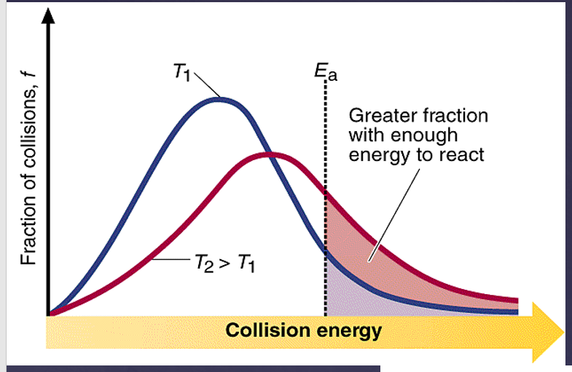
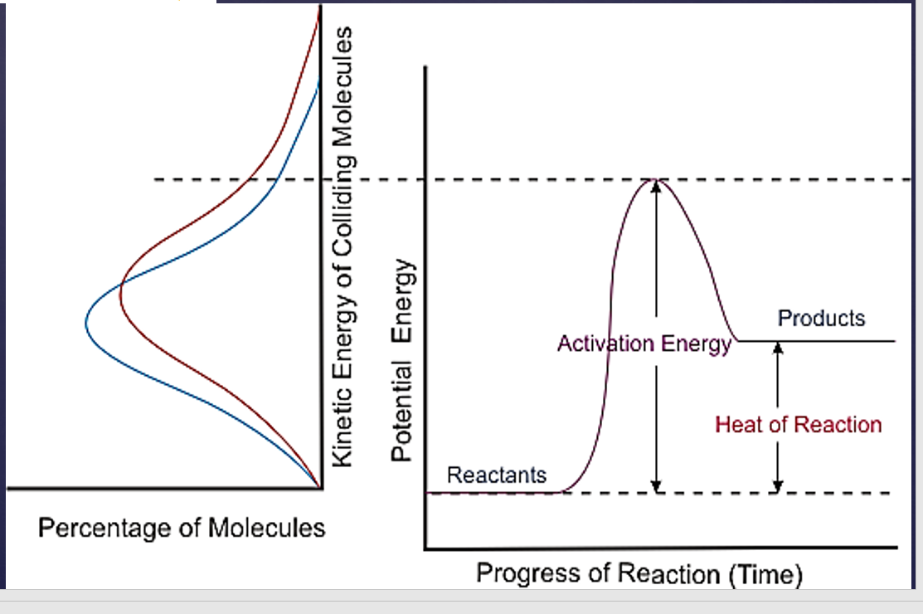
- Concentration.
Increasing concentration of reactants means decreased distance between reactant particles (more particles in the same space), increasing frequency of successful collisions, increasing reaction rate.
- Pressure.
Increasing pressure of reactants (by decreasing volume) means decreased distance between reactant particles (more particles in the same space), increasing frequency of successful collisions, increasing reaction rate.
- State of subdivision.
Increasing surface area of reactants exposes more reactant particles to each other at one time, increasing frequency of successful collisions, increasing reaction rate.
- Catalysts.
Catalysts provide an alternate reaction pathway which has a lower activation energy. This means a greater proportion of collisions have sufficient kinetic energy to meet the activation energy required for a successful collision, increasing reaction rate.
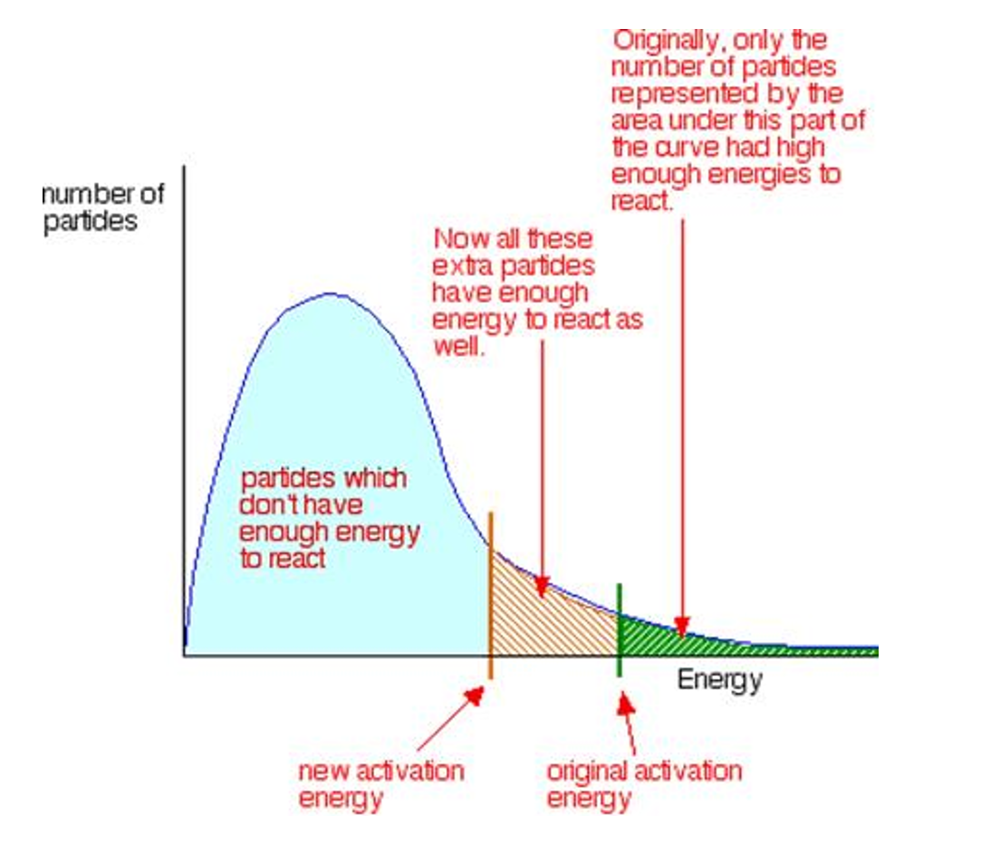

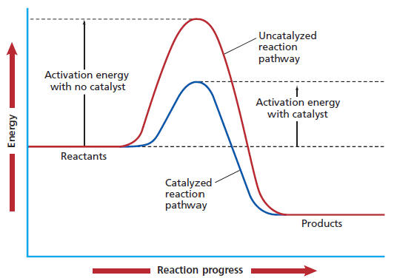

Equilibrium
Single arrow is indicates that the forward reaction is highly favoured.
Double arrow indicates that the reaction can occur readily in either direction. The extent to which the reaction proceeds depends on the nature of the reactants and reaction conditions.

Equilibrium occurs between reactants and products in a closed system – a system which allows energy to be exchanged with the surroundings but not matter. Equilibrium is denotated with the double arrow.
At equilibrium:
- The forward reaction rate is equal to the reverse reaction rate.
- There’s no change in macroscopic properties e.g., concentration, pressure or colour, temperature.

 | Rate
 | Explain
Temperature | Increasing temperature increases the average kinetic energy of reacting particles. This increases the proportion of collisions that have sufficient kinetic energy to meet the activation energy required for a successful collision, increasing reaction rate.  Increasing temperature increases the average kinetic energy of reacting particles, causing them to move faster, increasing frequency of collisions, increasing reaction rate.
Pressure/volume | Increasing pressure (by either decreasing volume or adding more of the same gas) decreases the distance between reacting particles, increasing frequency of collisions, increasing reaction rate.
Concentration/partial pressure | Increasing concentration/partial pressure of reactants decreases the distance between reacting particles, increasing frequency of collisions, increasing reaction rate.

 | Explain:  N_{2 (g)} + 3H_{2 (g)} ⇌ 2NH_{3 (g)} ΔH = –92kJ | State/predict/according to Le Châtelier:  N_{2 (g)} + 3H_{2 (g)} ⇌ 2NH_{3 (g)} ΔH = –92kJ
Temperature | Increasing temperature increases the rate of both the forward and reverse reaction but it increases the rate of the reverse reaction more. This increases the rate of the reverse reaction relative to the forward reaction so the equilibrium shifts left until a new equilibrium is established. | According to Le Châtelier, the system will react to partially counteract the imposed change. As such, increasing the temperature will favour the reverse endothermic reaction which decreases the temperature and the equilibrium shifts left until a new equilibrium is established.
Pressure/volume | Decreasing volume/increasing pressure decreases the distance between all particles, increasing frequency of collisions, increasing the rate of both the forward and reverse reactions. The rate of the forward reaction, which uses up the most particles, increases more. This increases the rate of the forward reaction relative to the reverse reaction so the equilibrium shifts right until a new equilibrium is established. | According to Le Châtelier, the system will react to partially counteract the imposed change. As such, increasing the pressure will favour the forward reaction which uses up the most particles and hence decreases pressure, so the equilibrium shifts right until a new equilibrium is established.
Concentration/partial pressure | Increasing concentration of H₂ decreases the distance between H₂ particles, increasing frequency of collisions, increasing the reaction rate of the forward reaction relative to the reverse reaction and the equilibrium shifts right until a new equilibrium is established. | According to Le Châtelier, the system will react to partially counteract the imposed change. As such, increasing the pressure will favour the forward reaction which uses up the H₂ particles and hence decreases [H₂], so the equilibrium shifts right until a new equilibrium is established.

Vapour Pressure Equilibrium
In a closed system, a little bit of liquid evaporates and at the same time some of the vapour condenses e.g., H₂O _{(l)} + heat ⇌ H₂O _{(g)} ΔH = [positive number]
At equilibrium:
- The rate of evaporation = rate of condensation.
- The vapour pressure and amount of fluid is constant.
Assuming dry air initially, the forward reaction would predominate as there’d be no liquid in the gaseous phase. As the vapour pressure increases, the closed system reaches equilibrium.
The equilibrium has a dynamic nature and the molecules are continually leaving and re-entering the liquid state from the vapour.

Q: What would happen to the system if the temperature of the system were raised?
More liquid particles have sufficient kinetic energy to leave the liquid phase and the rate of vaporization increases. Soon after (as there are more gaseous particles present), the rate of condensation increases until the rate of condensation equals the rate of vaporisation and a new equilibrium is achieved. At this new equilibrium, the volume of liquid will be less, and the vapour pressure will be higher.

Each liquid has a unique equilibrium vapour pressure at a specific temperature. The greater the vapour pressure, the more the equilibrium lies to the right (evaporation). This means the more readily the liquid evaporates. In general, the weaker the intermolecular forces between the liquid particles, the greater the vapour pressure.

Chemical Equilibrium
N_{2 (g)} + 3H_{2 (g)} ⇌ 2NH_{3 (g)} ΔH = –92kJ mol⁻¹
Changes in reaction rate:
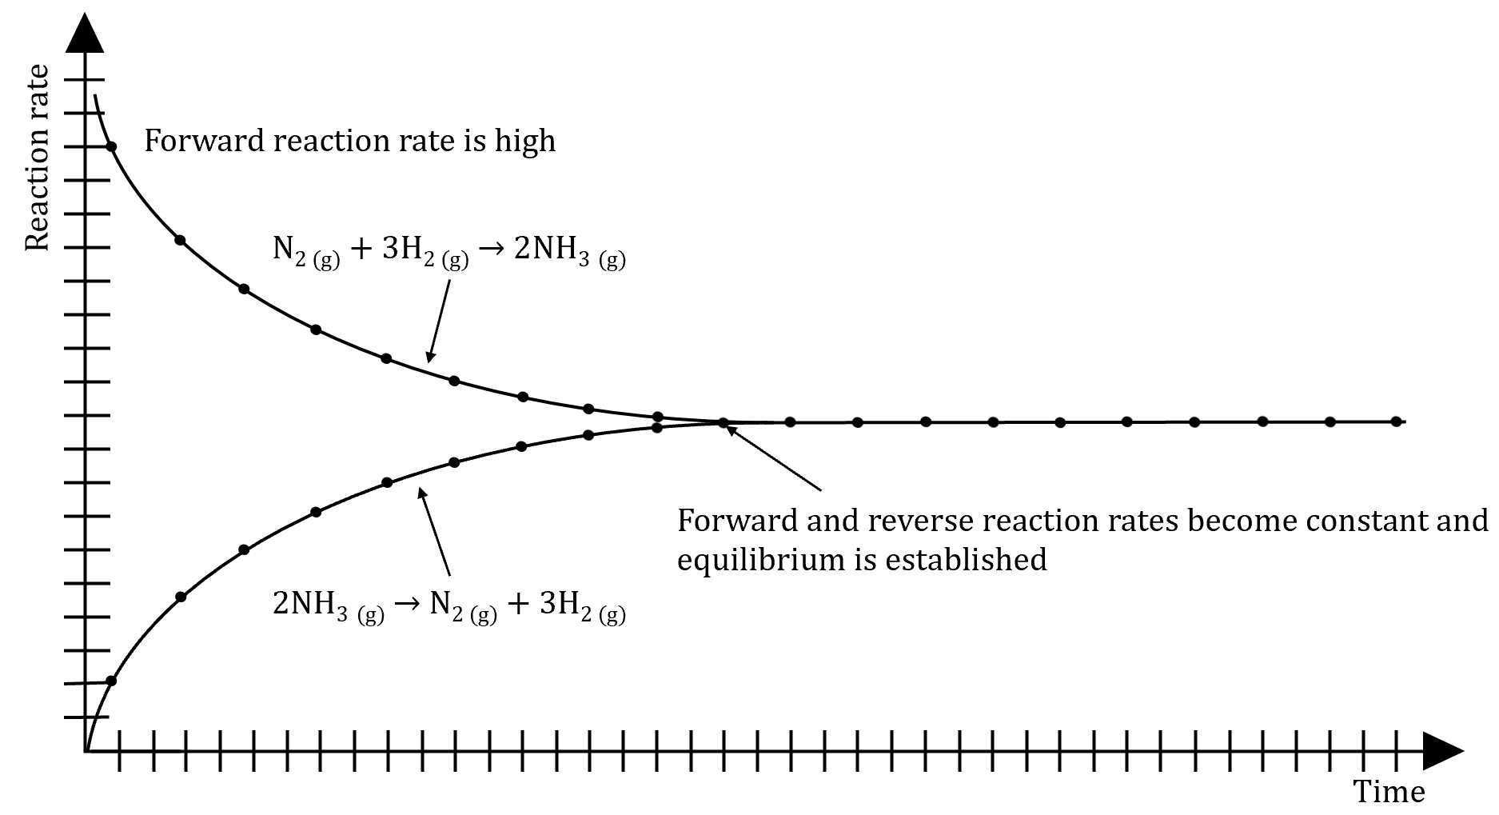
Initially only reactants are present and the forward reaction rate is high. As reactants are consumed, the forward reaction rate slows and eventually becomes constant. The reverse reaction rate increases as products are formed and it too eventually becomes constant.
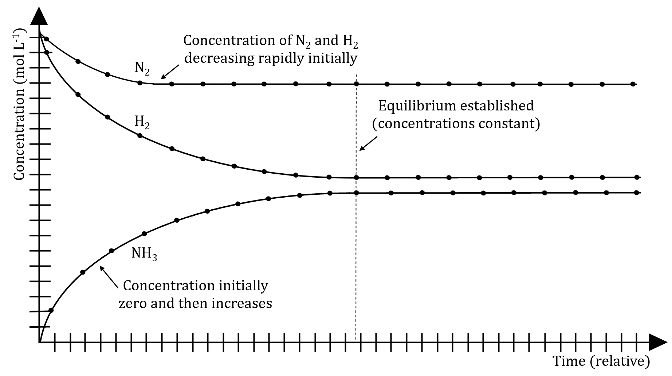
Initially only N_{2 (g)} and H_{2 (g)} are present at a concentration of 4mol L⁻¹. Equilibrium is established when concentrations remain constant.

When a (soluble) solid is placed in a liquid, the solid begins to dissolve. As more solid is added and saturation is achieved, it continues to dissolve but at the same time, some of the dissolved particles crystallise to reform solid.
At the point of saturation the rate of dissolution will equal the rate of crystallisation and equilibrium will be achieved. The amount of solid will remain constant as will the concentration of the ions in solution (as long as no changes are made to the system).

Q: What would happen to the system if the temperature of the system were increased?
If the temperature is increased more solid particles will have sufficient energy to dissolve into the solution and the rate of dissolution increases. Soon after, the rate of crystallization increases until the rate of crystallization equals the rate of dissolution and a new equilibrium is established. At this new equilibrium, the amount of solid would be less and the concentration of the solution will be greater.

K > 1 → [products] > [reactants] → Reaction favours products.
K >> 1 (e.g., 10³) → [products] >> [reactants] → Reaction strongly favours products.
K < 1 → [products] < [reactants] → Reaction favours reactants.
K << 1 (e.g., 10⁻³) → [products] << [reactants] → Reaction strongly favours reactants.
K ≈ 1 → [products] ≈ [reactants] → Concentration of products and reactants are similar.

aA + bB ⇌ cC + dD
$$K=\frac{{[C]}^{c}{[D]}^{d}}{{[A]}^{a}{[B]}^{b}}$$
Note:
- Solids and liquids aren’t included in the K expression. The concentrations of a solid and water don’t vary in an aqueous solution. Gases and aqueous solutions are included.
- The value of K doesn’t change if you alter concentration, pressure or volume.
- The value of K varies with temperature. If temperature is increased, the value of K increases for endothermic reactions (favouring products) and decreases for exothermic reactions (favouring reactants).
- The value of K refers only to the equilibrium position.
No matter what the initial concentrations of the reactants or products, the value of the equilibrium constant will always be the same (provided it is measured under the same temperature conditions).

CH₃COOH as it has the higher K_{c} value which indicates more products present at equilibrium. As acid strength is based on [H₃O⁺] in solution, this means CH₃COOH is stronger.
It’s important to understand that the equilibrium constant gives no information about the rate of a reaction.

Le Châtelier’s principle:
If a change in conditions is made to a chemical system in equilibrium, the system will adjust in such a way as to partially counteract the imposed change.
For a system at equilibrium this means that:
- Increasing the concentration of a substance will favour the reaction which uses up that substance.
- Increasing the pressure of a gas will favour the reaction which decreases the pressure.
- Increasing the temperature of the system will favour the reaction which will lower the temperature.

Increasing concentration of reactants:
- The forward reaction rate would increase while the reverse reaction rate wouldn’t initially be effected since the concentration of the product(s) hasn’t changed.
- As more product(s) is produced, the reverse reaction rate also begins to increase.
- A new equilibrium would eventually be reached with identical new forward and reverse reaction rates.

If a species’ concentration is decreased, the equilibrium will shift to try to increase the concentration of that particular species.
If a species’ concentration is increased, the equilibrium will shift to try to decrease the concentration of that particular species.

PCl_{3 (g)} + Cl_{2 (g)} ⇌ PCl_{5 (g)}
Further Cl₂ is added.
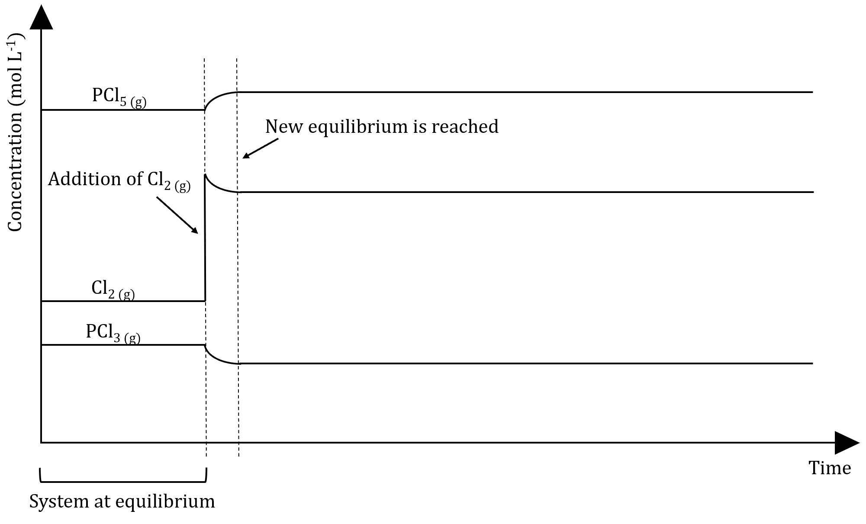

Cr₂O₇²⁻_{(aq)} + 2OH‒_{(aq)} ⇌ 2CrO₄²⁻_{(aq)} + H₂O_{(l)}
Q: Draw a labelled concentration-time graph and a labelled reaction rate-time graph that shows the first equilibrium being achieved when a solution of potassium dichromate is added to a solution of sodium hydroxide.
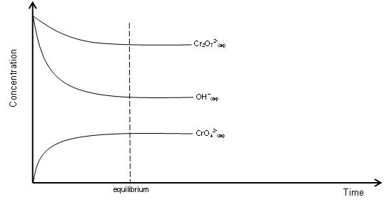
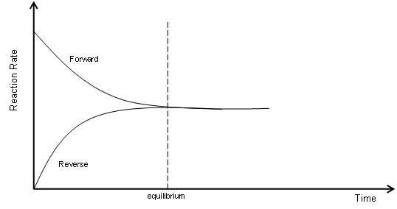
Q: What would you observe as equilibrium is achieved?
An orange solution added to a colourless solution to become an orange/yellow solution.

Q: Predict and justify the change in equilibrium if a small amount of potassium dichromate is added to the system at equilibrium.
The equilibrium will shift to counteract the added potassium dichromate. The forward reaction will be favoured which decreases the concentration of potassium dichromate and the equilibrium shifts right until a new equilibrium is established.

Q: What would you observe?
An orange solution is added to an orange/yellow solution which then becomes more yellow.

Q: Explain the change in equilibrium.
By adding more K₂Cr₂O₇ you are increasing [Cr₂O₇²⁻]. This increases the forward reaction rate (increased frequency of collisions) relative to the reverse reaction. After a time, the forward reaction rate begins to slow down as the reverse reaction rate increases until the rate of the forward and reverse reactions are equal (i.e. a new equilibrium is achieved).

Q: On the previous concentration-time and reaction rate-time axes continue the diagrams so that they show the second equilibriums being achieved when extra potassium dichromate is added to the solution at equilibrium.
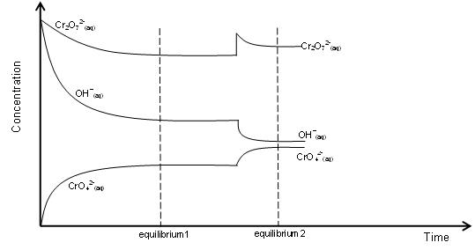
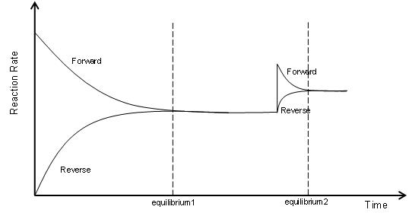
The concentration of all species in a system can be manipulated by adding or evaporating the solvent (usually water).

When adding water to the entire system, this has the effect of reducing the concentration of all species. This will increase the distance between all the particles, reducing frequency of collisions, reducing the rate of both the forward and reverse reactions. The rate of the reaction that uses up the most particles will be decreased the most (based on relative proportions) and so the reaction that produces more particles will occur at a greater rate (be favoured) until equilibrium is re-established.

When removing water from the entire system (i.e. evaporation), this has the effect of increasing the concentration of all species. This will decrease the distance between all the particles which increases the frequency of collisions and so increases the rate of both the forward and reverse reactions. The rate of the reaction that uses up the most particles will be increased the most (based on relative proportions) and so the reaction that produces less particles will occur at a greater rate (be favoured) until equilibrium is re-established.

Note: The side with the most particles will always be affected the most.

Co(H₂O)₆²⁺ _{(aq)} + 4Cl– ⇌ CoCl₄^{2–} _{(aq)} + 6H₂O _{(l)}
Q: Using the system above, predict and justify which way the equilibrium will shift (if at all) when water is added to the system.
Adding water will decrease the concentration of all species. The equilibrium will shift to partially counteract the imposed change and favour the reverse reaction which increases the concentration of species as it produces more particles. The equilibrium shifts left until a new equilibrium is established.

Q: Give the observations for this change.
Colourless solution added to pink/blue solution. Solution becomes more pink.

Q: Explain this change in equilibrium.
Adding water reduces the concentration of all species. This will increase the distance between all the particles which reduces the frequency of collisions and so reduces the rate of both the forward and reverse reactions. The rate of the forward reaction that uses up the most particles will be decreased the most (based on relative proportions) and so the equilibrium shifts left until equilibrium is re-established.

Effect of changing pressure or volume of a gas:
In equilibrium systems, changing the volume of a gas can alter the pressure and hence the concentration of all species. This will cause a change in both the forward and reverse reaction rates. The favoured reaction direction will depend on the number of gas particles present in the reactants and products.

N_{2 (g)} + O_{2 (g)} ⇌ 2NO _{(g)}
An increase in pressure will have no effect on the equilibrium position. Both forward and reverse reactions increase equally since the number of gas particles are the same. Hence there’s no change in equilibrium position, just a change in reaction rate.

N_{2 (g)} + 3H_{2 (g)} ⇌ 2NH_{3 (g)}
An increase in pressure will favour the side with the least number of molecules. This is in accordance with Le Châtelier’s principle. When the pressure is increased, the number of gas particles in a given volume increases. The system will oppose this change by favouring the reaction that produces the least number of particles. In this reaction, the favoured reaction direction would be to the right.

Once a system achieves new equilibrium after pressure change:
- Total number of molecules is less.
- Total new pressure is less than after initial change.
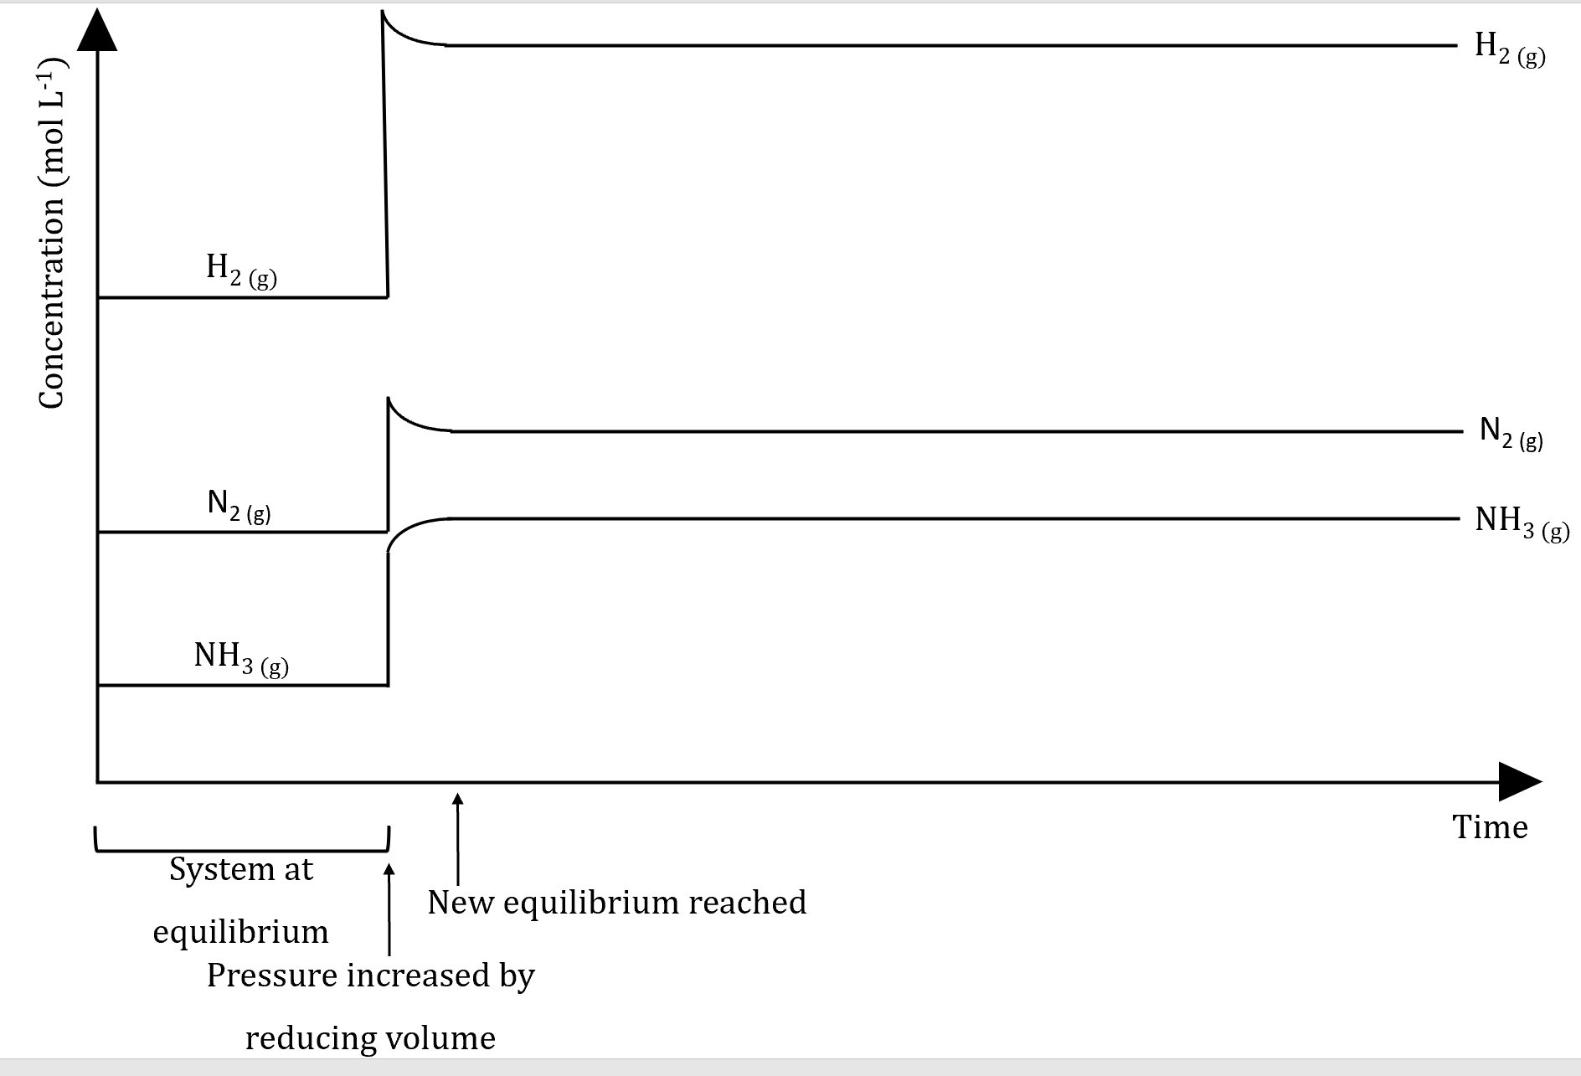
If the volume of the system is increased, this decreases the total pressure. The equilibrium will shift to try to increase the total pressure again which means it will favour the side with the greater number of particles (increasing the total number of moles of gaseous particles in the system).

If both sides of the equilibrium have the same number of relative particles, there is no change in the position of the equilibrium.

When increasing the volume of the system (i.e. decreasing the pressure of the system), this will increase the distance between all the particles which reduces the frequency of collisions and so reduces the rate of both the forward and reverse reactions. The rate of the reaction that uses up the most particles will be decreased the most (based on relative proportions) and so the reaction that produces more particles will occur at a greater rate (be favoured) until equilibrium is re-established.

When decreasing the volume of the system (i.e. increasing the pressure of the system), this will decrease the distance between all the particles which increases the frequency of collisions and so increases the rate of both the forward and reverse reactions. The rate of the reaction that uses up the most particles will be increased the most (based on relative proportions) and so the reaction that produces less particles will occur at a greater rate (be favoured) until equilibrium is re-established.

Note: The side with the most particles will always be affected the most).

When the volume is increased, the concentration (or partial pressure) of each species will change relative to the others.
Similarly, when it returns to equilibrium, although they approach their original concentrations, the final concentrations will never equal (or go above or below) the initial concentrations at equilibrium.

N_{2 (g)} + 3H_{2 (g)} ⇌ 2NH_{3 (g)}
Q: What would you observe as equilibrium is achieved?
No observable change.
(All gases are colourless and if it is closed, assume formation of pungent ammonia gas cannot be detected).

Q: Predict and justify the change in equilibrium if the total volume of the cylinder is increased.
As volume increases, total pressure decreases.
According to Le Châtelier’s the system will react to partially counteract the change. As such, decreasing the pressure favours the reverse reaction which increases the pressure, as it produces more particles, and the equilibrium shifts left until a new equilibrium is established.

Q: Explain the change in equilibrium.
Increasing the volume of the system increases the distance between all particles. This reduces the frequency of collisions which decreases the rate of both the forward and reverse reactions. As the ratio of reactants to products is 4:2, the rate of the forward reaction (which uses up the most particles) will decrease more than the reverse reaction. The reverse reaction occurs at a greater rate relative to the forward reaction and the equilibrium shifts left until a new equilibrium is established.

Effect of changing temperature:
2NO _{(g)} + O_{2 (g)} ⇌ 2NO_{2 (g)} + 113kJ
If heat is added to a system at equilibrium, the system reaction will move in the direction that uses up that heat. Both the forward and reverse reaction rates increase except that the reverse reaction rate increases to a greater extent initially.
Increasing the temperature of the system will favour the endothermic reaction as it decreases the temperature.
Decreasing the temperature of the system will favour the exothermic reaction as it increases the temperature.

I_{2 (g)} + H_{2 (g)} ⇌ 2HI _{(g)}
Q: What would you observe as equilibrium is achieved?
Purple gas added to a colourless, odourless gas which becomes a paler purple gas.

Q: Predict and justify the change in equilibrium if the cylinder is cooled.
According to Le Châtelier, the system will react to partially counteract the change. As such, decreasing the temperature of the system will favour the reverse exothermic reaction as it increases the temperature and the equilibrium shifts left until a new equilibrium is established.

Q: What would you observe?
The pale purple gas becomes a darker purple.

Q: Explain the change in equilibrium.
Cooling the system (decreasing the temperature) decreases the average kinetic energy of the particles which means fewer collisions have enough energy to meet the activation energy required. This decreases the frequency of successful collisions.
Also, as particles are moving slower, the frequency of collisions decreases.
Both the rate of forward and reverse reactions decrease but the rate of the endothermic reaction, which in this case is the forward reaction, decreases more.
This means the rate of the reverse reaction is greater relative to the forward and the equilibrium shifts left until a new equilibrium is established.

Effect of using catalysts:
Catalysts effectively provide a lower activation energy pathway for a reaction and hence help increase both the forward and reverse reaction rates. Hence catalysts don’t affect equilibrium position that are useful in helping reaction achieve equilibrium quicker.
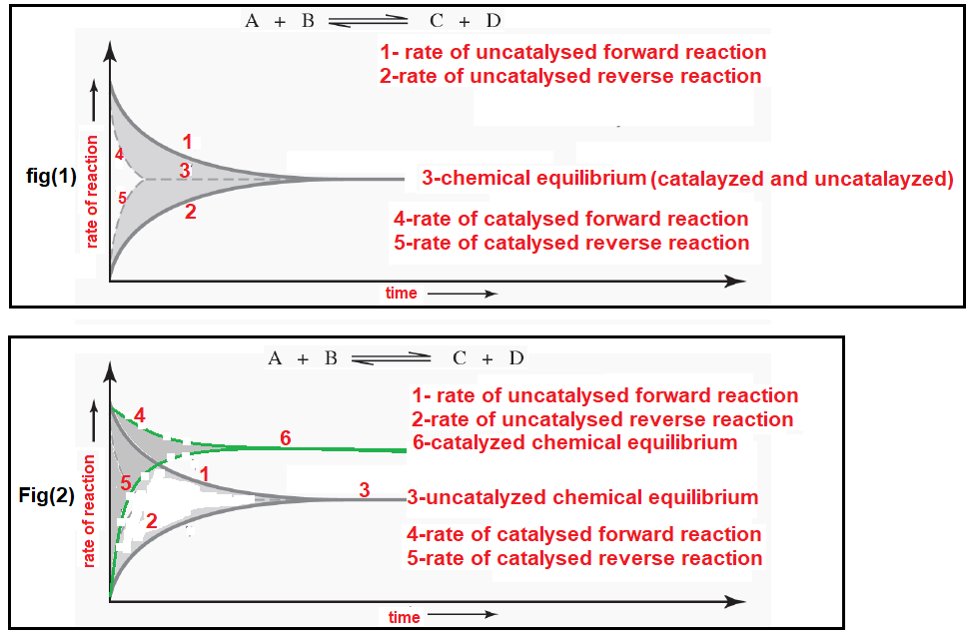
An imposed change to a system may cause changes to:
- Reaction rate (forward and/or reverse).
- Concentration of reactants/products.
- Equilibrium position (usually).
- Temperature.

Manipulating pressure (total or partial), concentrations and/or the addition of catalysts does not impact the equilibrium constant.
Only temperature will change an equilibrium constant.

If the forward reaction is endothermic, an increase in temperature will cause an increase in the equilibrium constant.
Conversely, an increase in temperature will cause a decrease in the equilibrium constant if the forward reaction is exothermic (and vice versa).

CO₂ Equilibrium in Water
$${CO}_{2 \left(g\right)}⇌{CO}_{2 \left(aq\right)}$$
$${CO}_{2 \left(aq\right)}+H_{2}O_{ \left(l\right)}⇌H_{2}{CO}_{3 \left(aq\right)}$$
$$H_{2}{CO}_{3 (aq)}+H_{2}O_{ (l)}⇌H_{3}{O^{+}}_{(aq)}+{{{HCO}_{3}}^{-}}_{\left(aq\right)}$$
$${{{HCO}_{3}}^{-}}_{(aq)}+H_{2}O_{ (l)}⇌{H_{3}O^{+}}_{(aq)}+{{{CO}_{3}}^{2-}}_{(aq)}$$
This affects the acidity of the water (H₃O⁺_{(aq)} ions) but also provides the carbonate ions necessary for the formation of calcium carbonate structures in a variety of marine organisms. A current concern is that the increased levels of CO₂ in the atmosphere cause more of it to dissolve in ocean waters, leading to an increase in ocean acidity and possible negative effects on marine ecosystems, in particular the increased acidity reduces the calcification process necessary for many marine organisms.

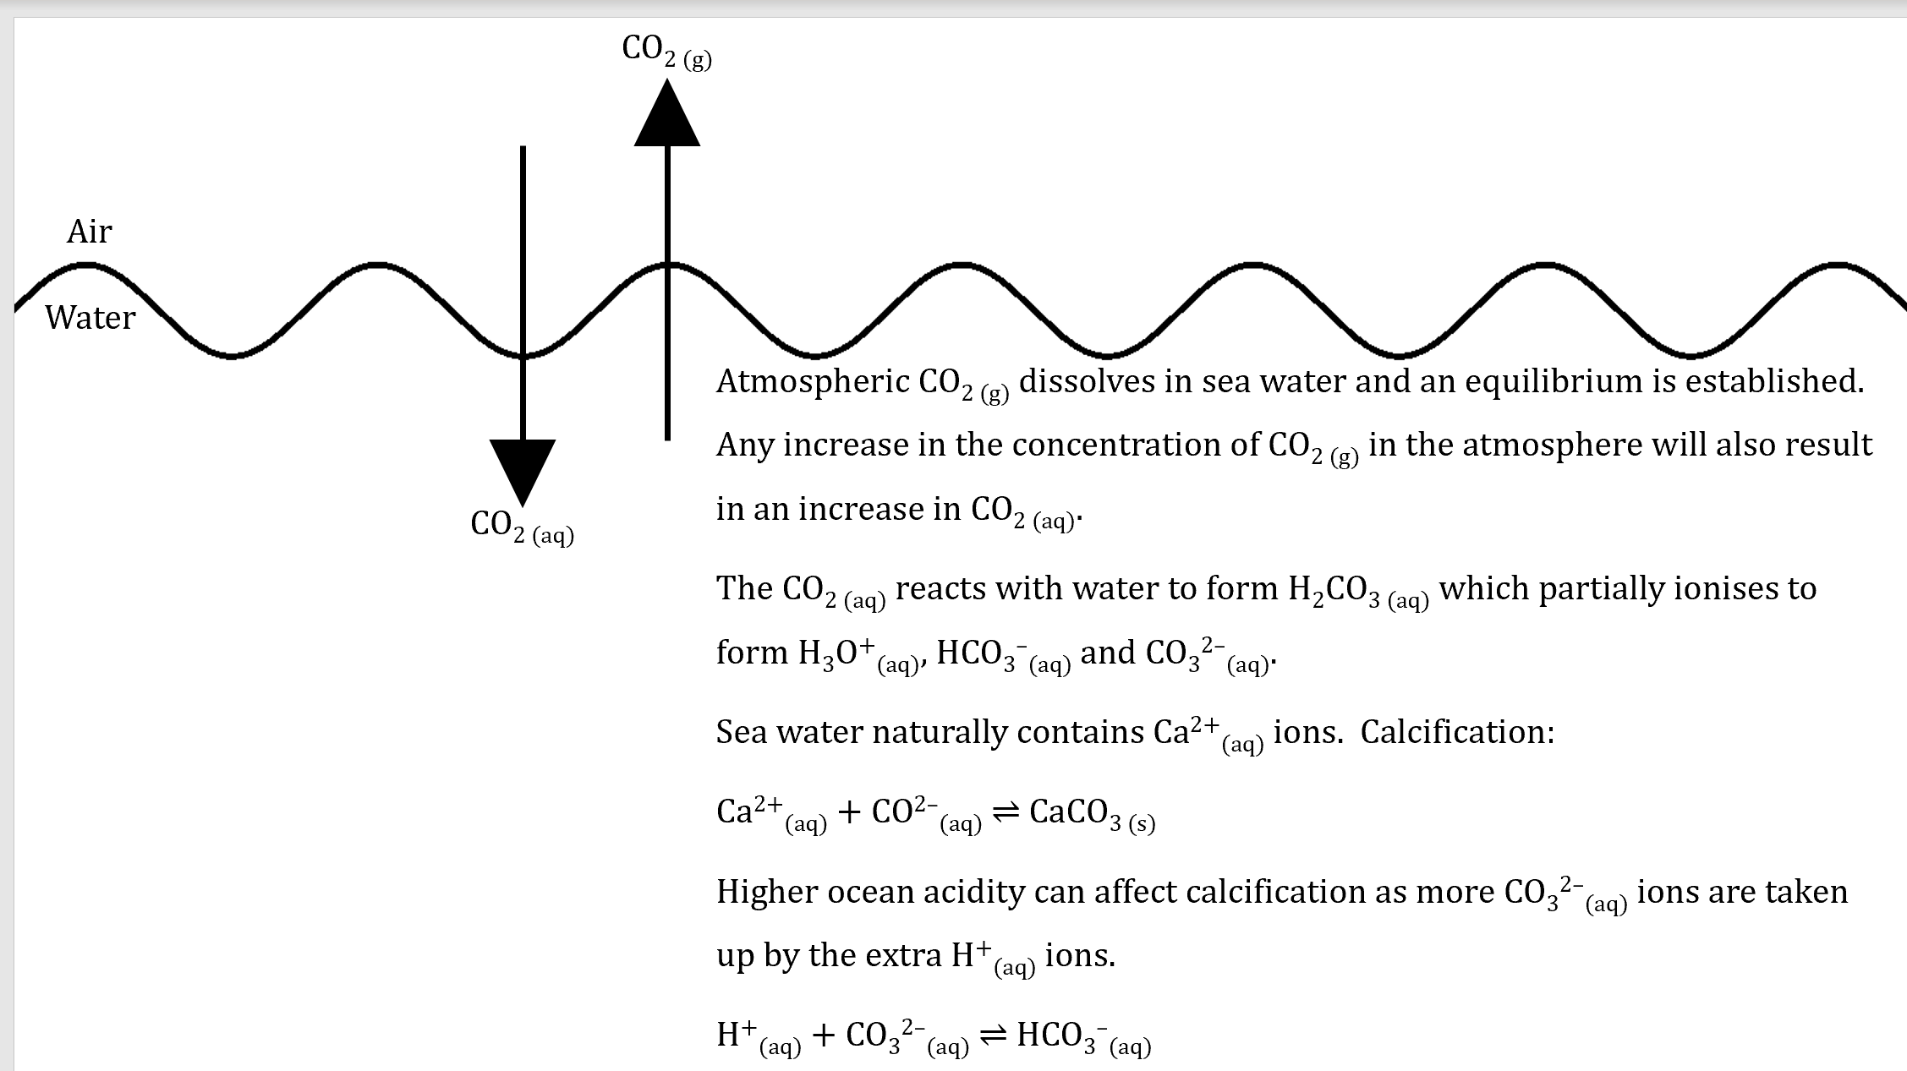

CO_{2 (g)} ⇌ CO_{2 (aq)}
CO_{2 (aq)} + CO₃^{2–}_{(aq)} + H₂O _{(l)} ⇌ 2HCO₃–_{(aq)}
Ca²⁺_{(aq)} + CO₃^{2–} ⇌ CaCO_{3 (s)}

CO_{2(g)} ⇌ CO_{2(aq)}
CO_{2(aq, ocean)} + H₂O_{(l)} ⇌ H₂CO_{3(aq)}
H₂CO_{3(aq)} + H₂O_{(l)} ⇌ HCO₃‒_{(aq)} + H₃O⁺_{(aq)}
HCO₃‒_{(aq)} + H₂O_{(l)} ⇌ CO₃^{2‒}_{(aq)} + H₃O⁺_{(aq)}
CaCO_{3(s)} + 2 H₃O⁺_{(aq)} ⇌ Ca²⁺_{(aq)} + CO_{2(g)} + 3 H₂O_{(l)}
Additionally: CO₃^{2‒}_{(aq)} + H₃O⁺_{(aq)} ⇌ HCO₃‒_{(aq)} + H₂O_{(l)}

